OAuthDemo project

Select Authentication Type: Individual Accounts
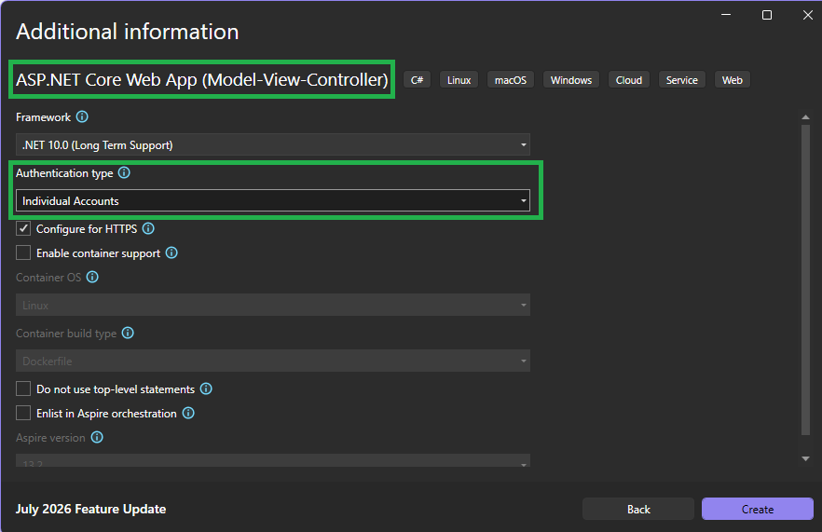

For the google Authentication for OAuth, do the following setps:
- Go to the following:
https://console.cloud.google.com/welcome/new?pli=1

- Click on ‘Select a project’

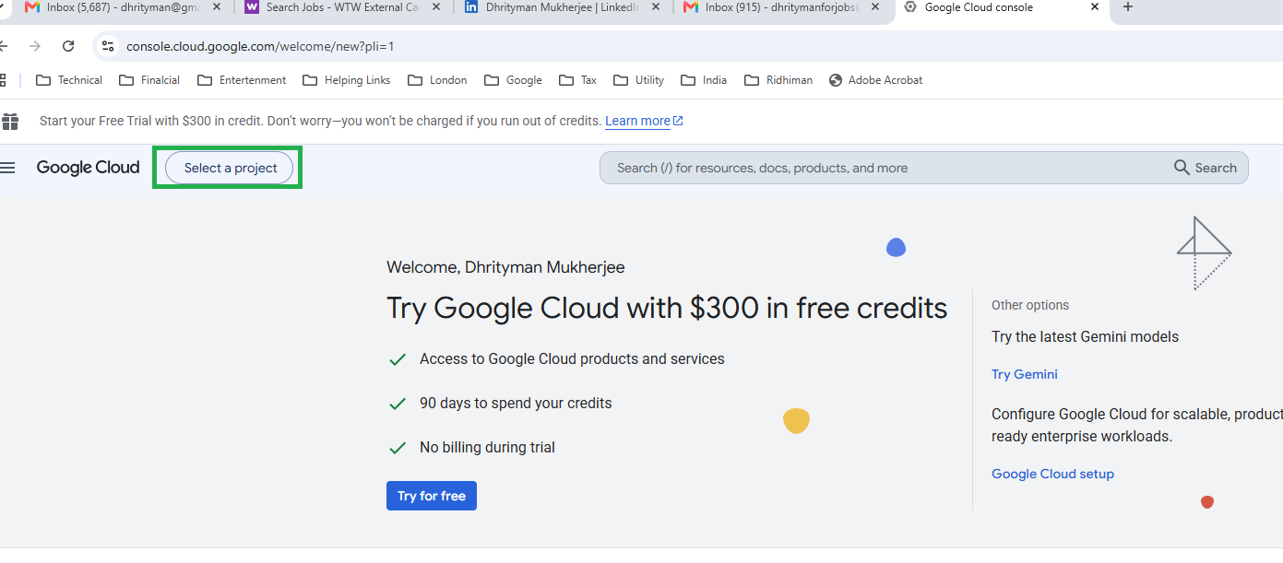
- Click on ‘Net Project
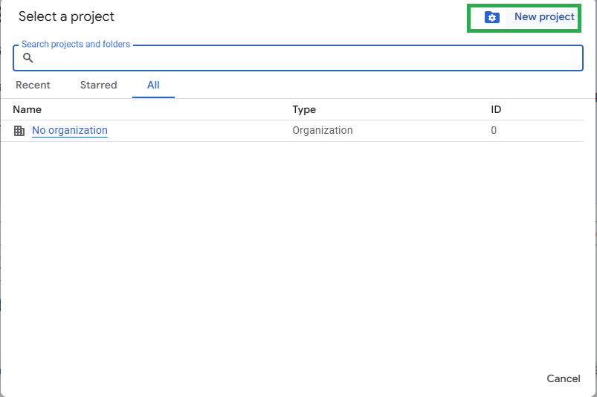
- Give the Project Name ‘OAuthDemoGoogleProject’ and Click ‘Create’
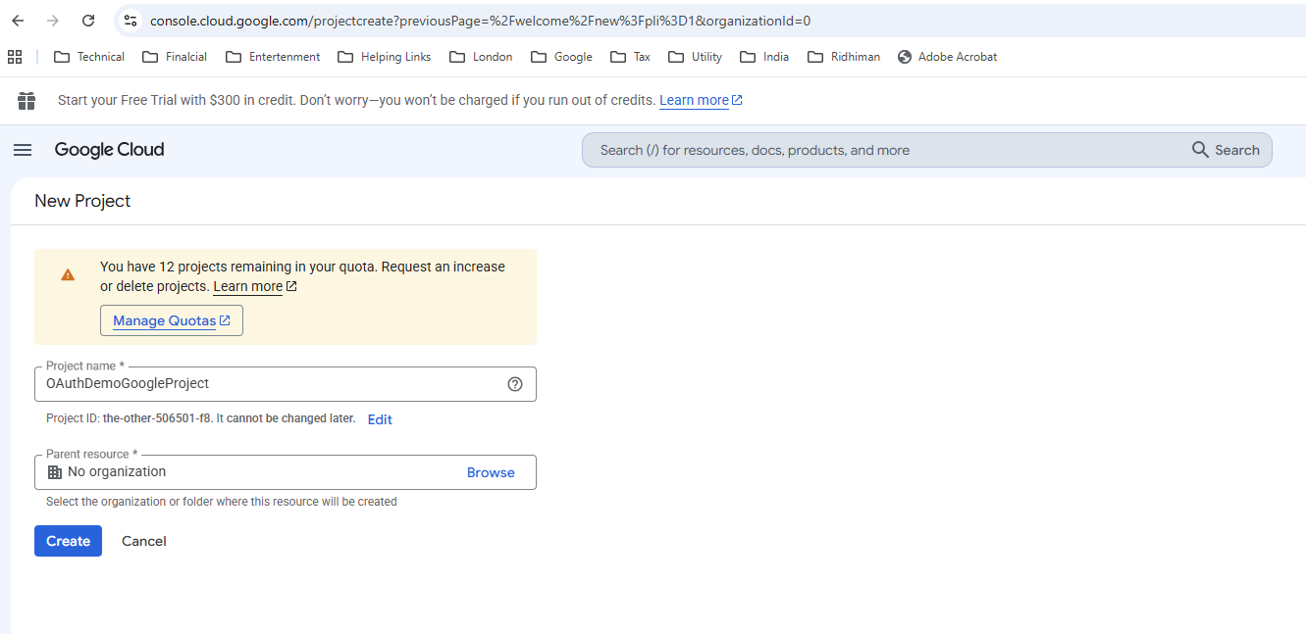

- Click on ‘Select Project’
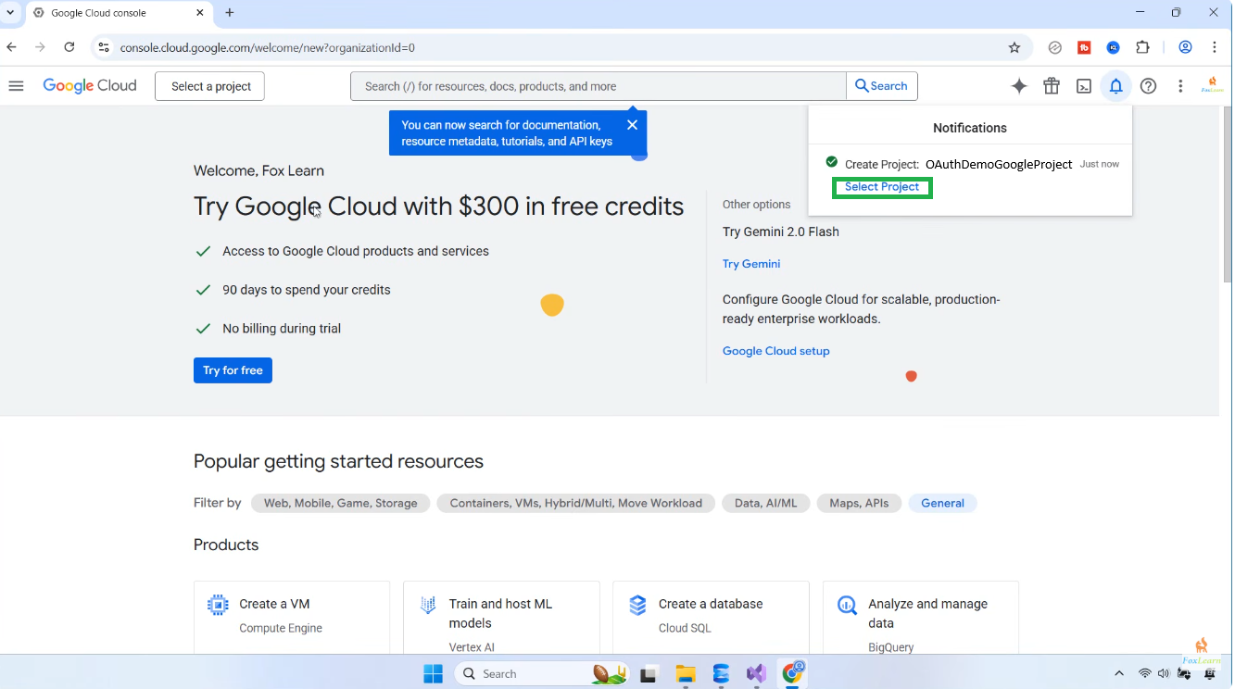

- Click on ‘APIs & Services’=> ‘OAuth consent screen’

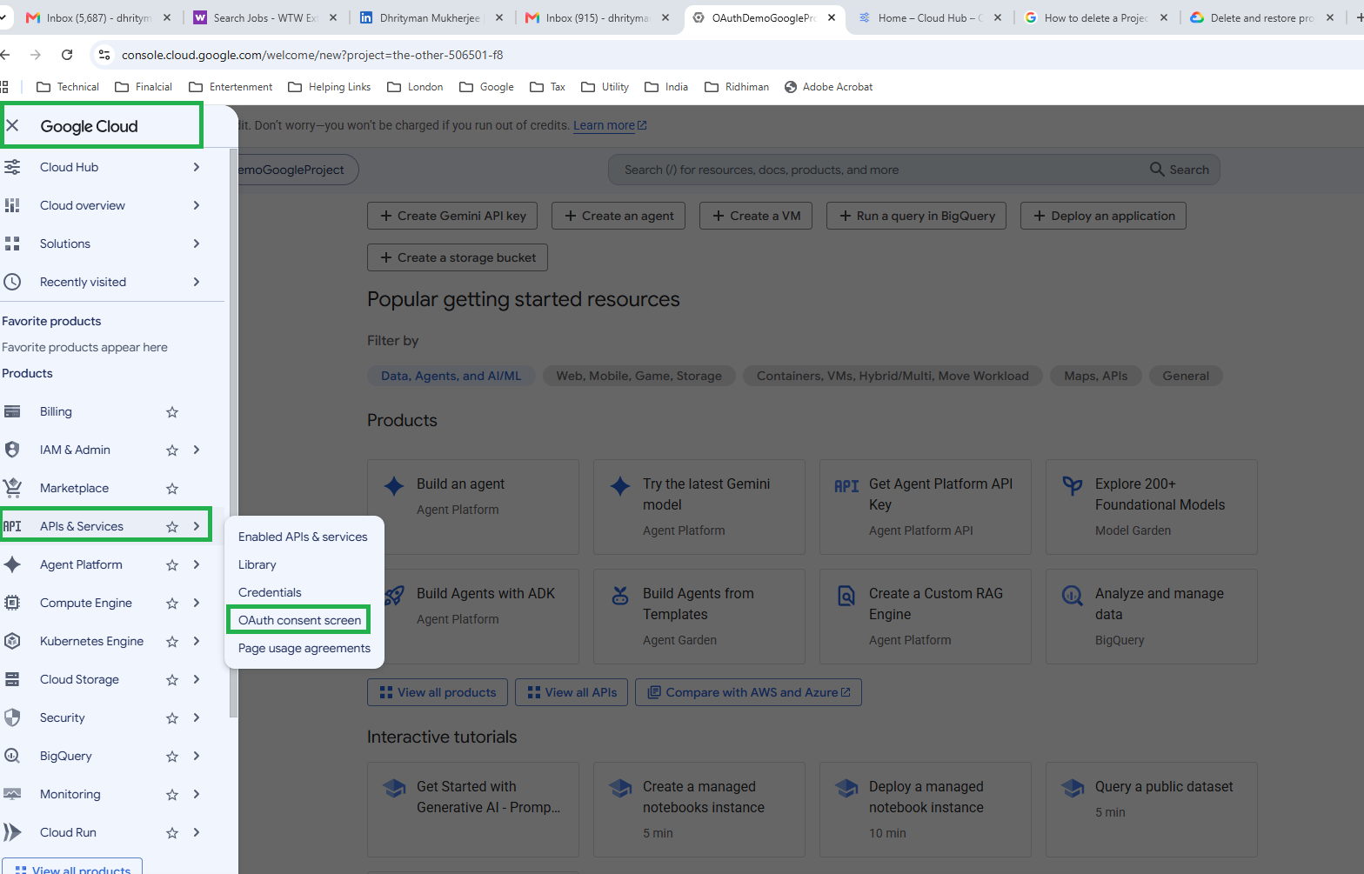

- Click on ‘Get started’

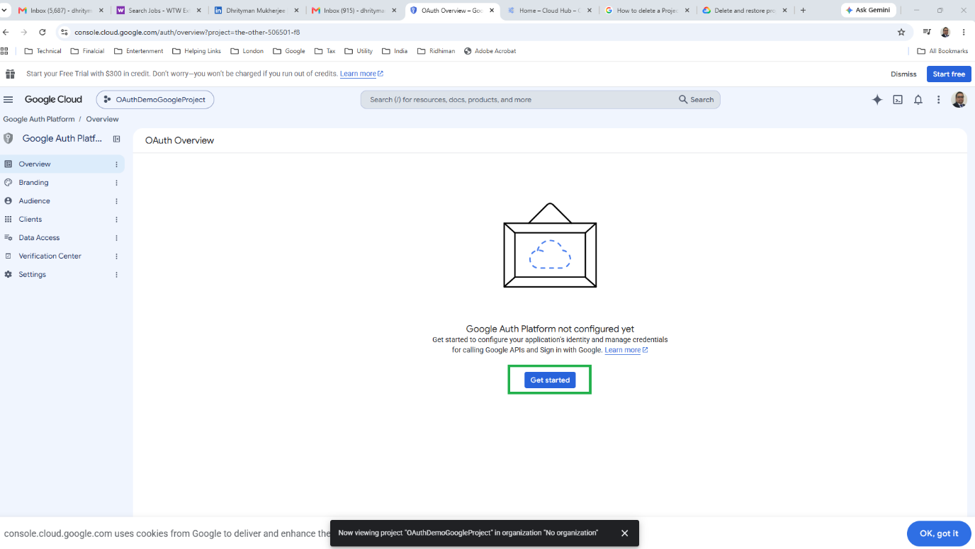

- Give the Following and Click ‘Next’ button
App Name: OauthDemo
User support email:dhrityman@gmail.com

OAuthDemo project

Select Authentication Type: Individual Accounts


For the google Authentication for OAuth, do the following setps:
- Go to the following:
https://console.cloud.google.com/welcome/new?pli=1

- Click on ‘Select a project’


- Click on ‘Net Project

- Give the Project Name ‘OAuthDemoGoogleProject’ and Click ‘Create’


- Click on ‘Select Project’


- Click on ‘APIs & Services’=> ‘OAuth consent screen’



- Click on ‘Get started’



- Give the Following and Click the ‘Next’ Button
App Name: OauthDemo
User support email:dhrityman@gmail.com
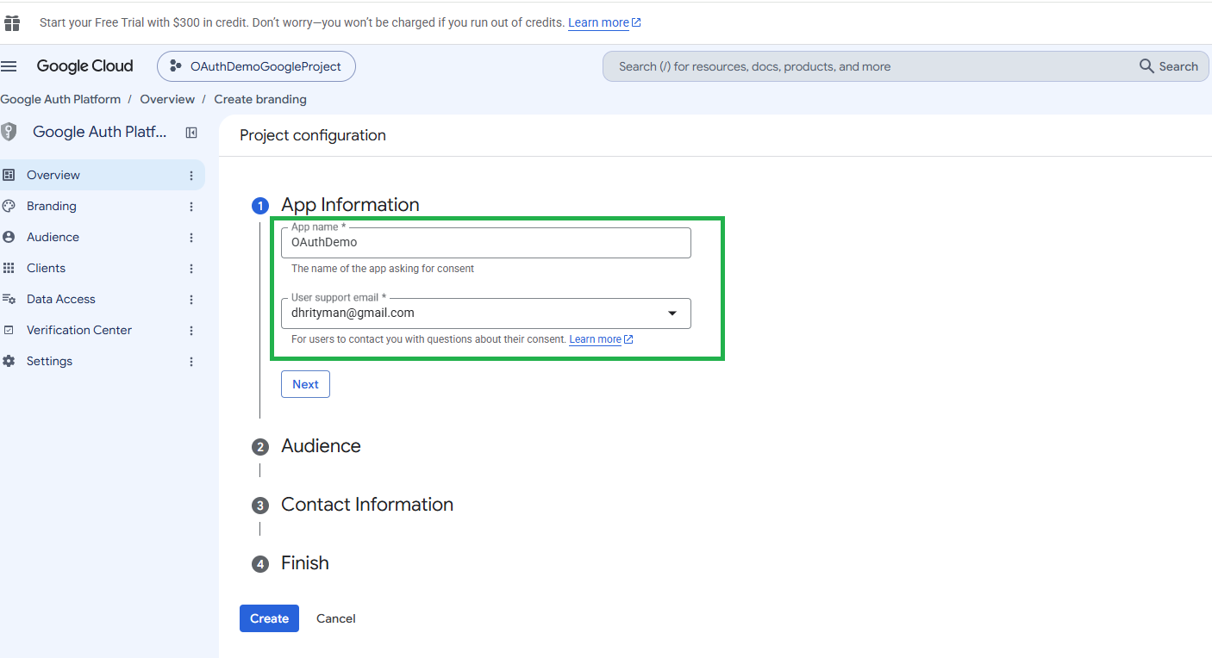

- On clicking the ‘Next’ button
Select Project configuration type is ‘External’
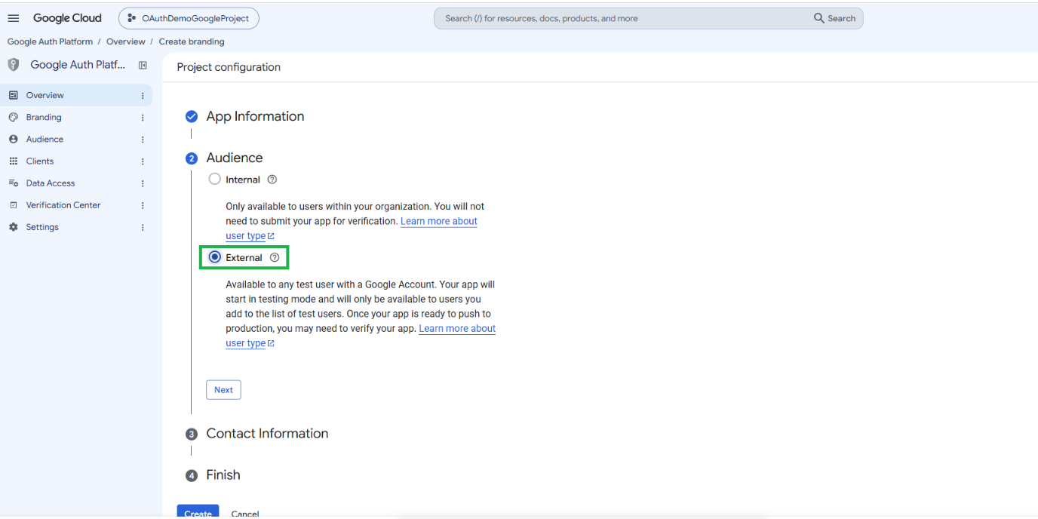

- Click on ‘Next’ Button and Give the Email address
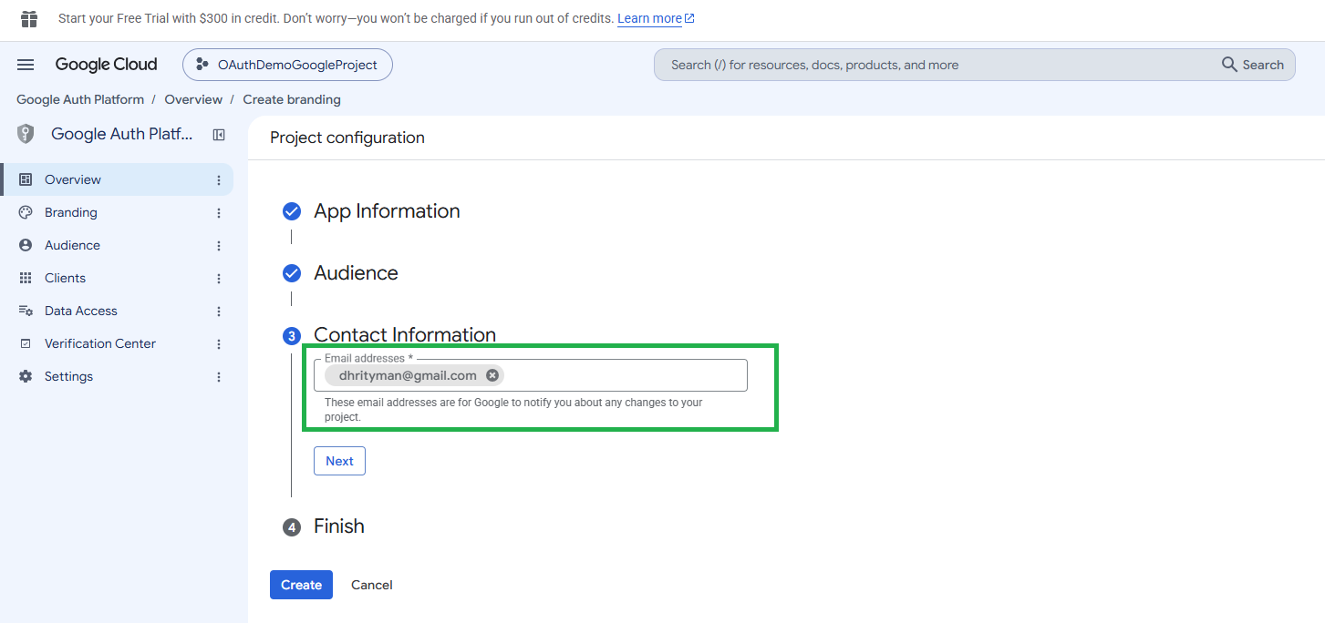

- Click on ‘Next’ Button and agree the Data Policy and again click ‘Continue’
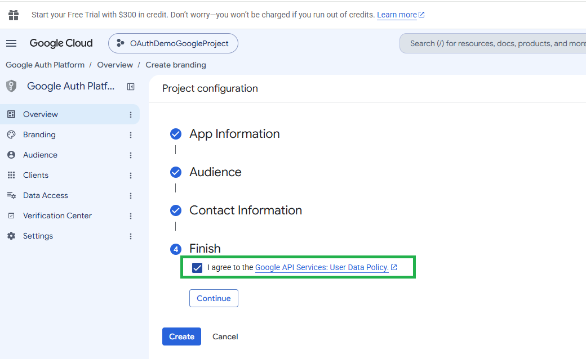

- Click on ‘Create’ Button
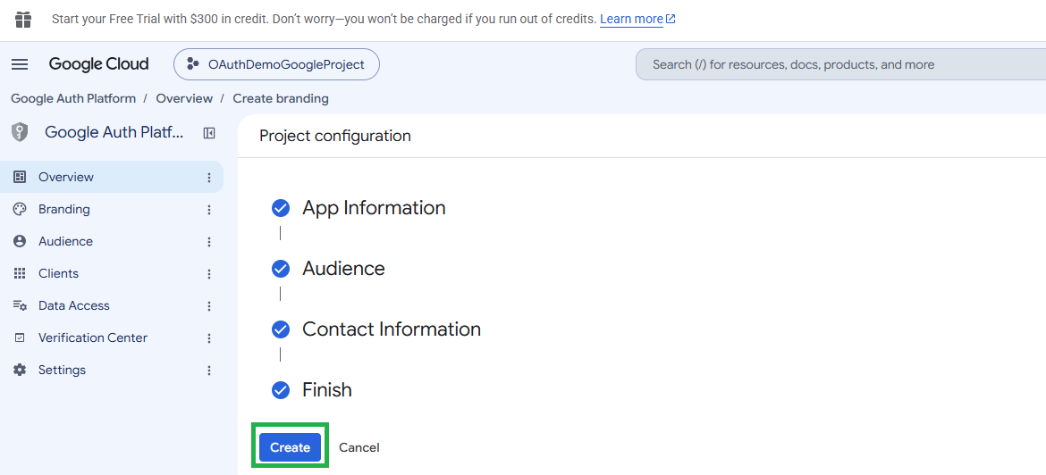
- Click the Button ‘Create Oauth client’ button
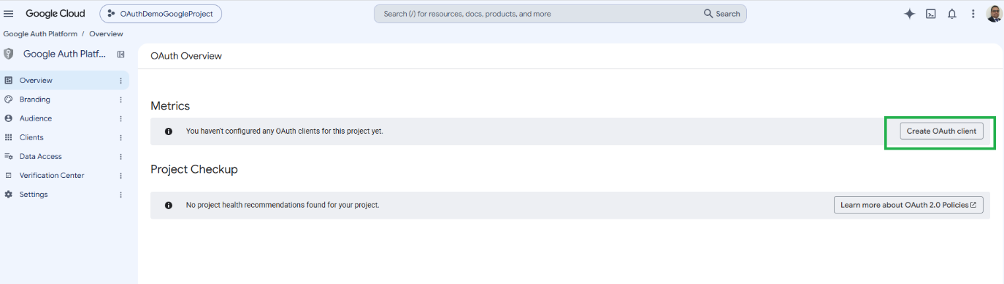

- Select Application Type=’Web Application’
and for Oauth Client Name
‘Name’=AuthDemo

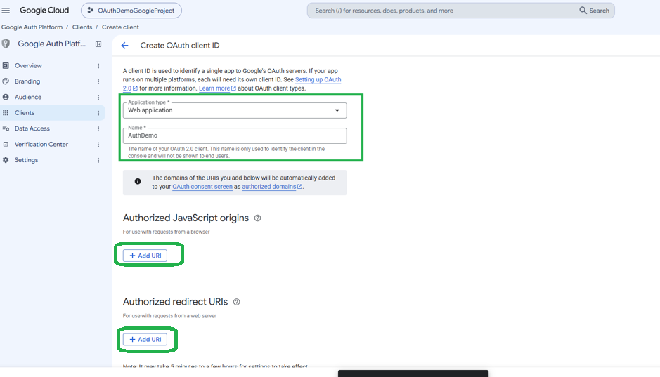

- Click on ‘Add URI on both

  - Authorized JavaScript Origin
  - Authorized redirect URIs
Run the project and
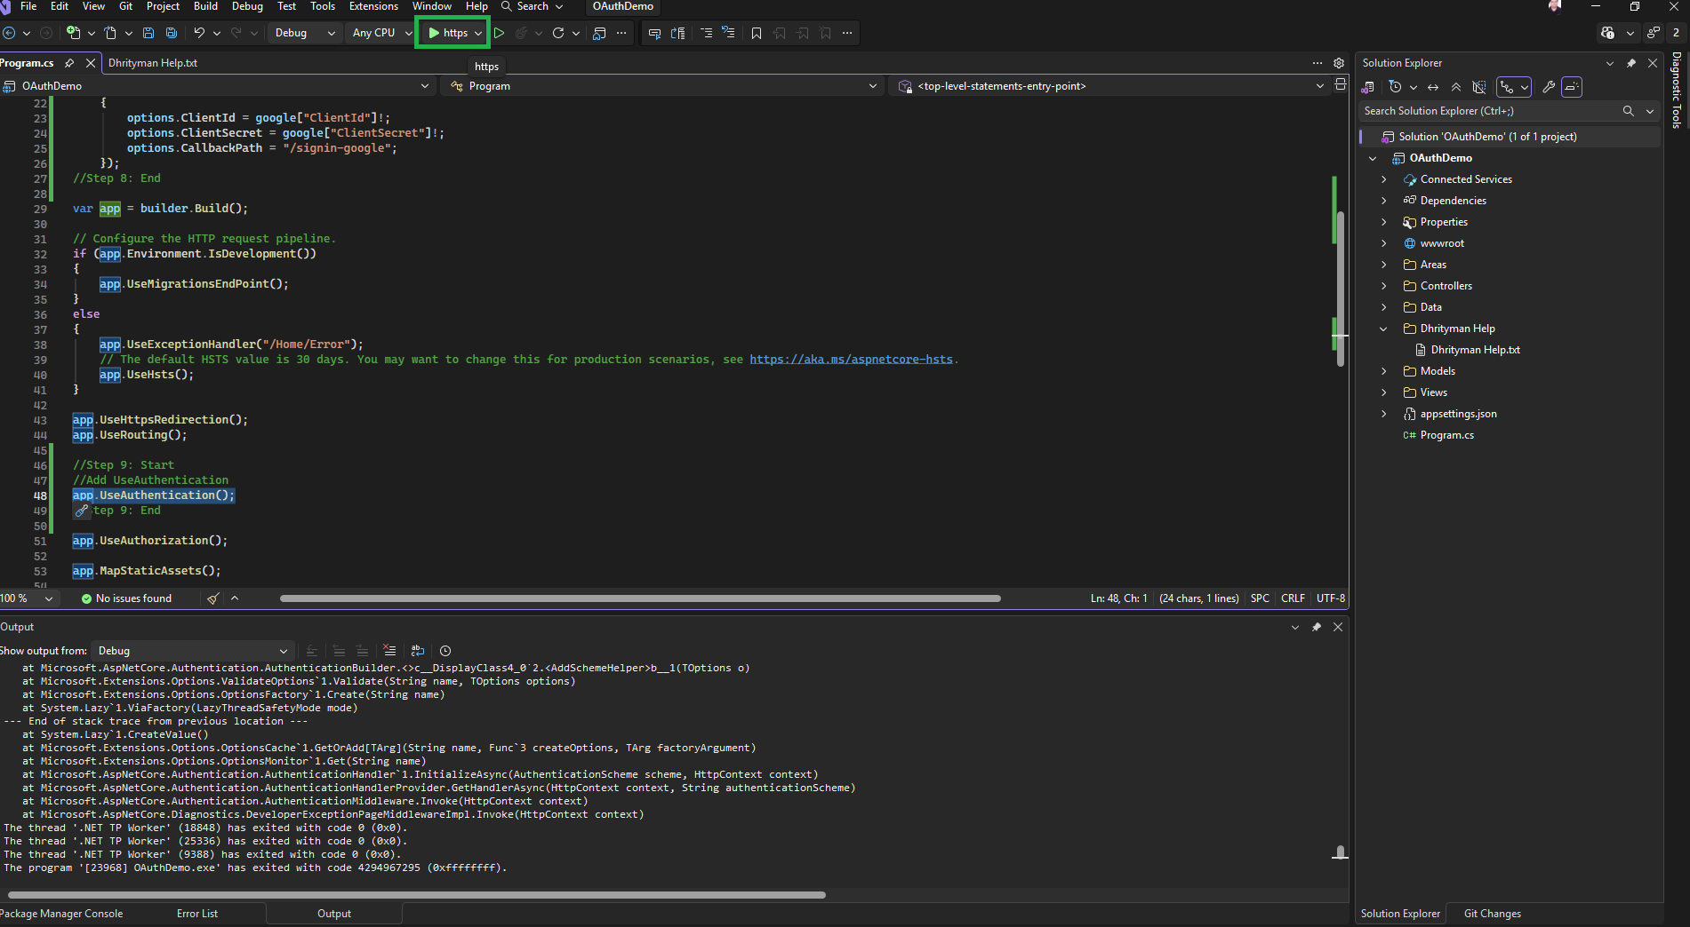

Copy the URL

https://localhost:7193/
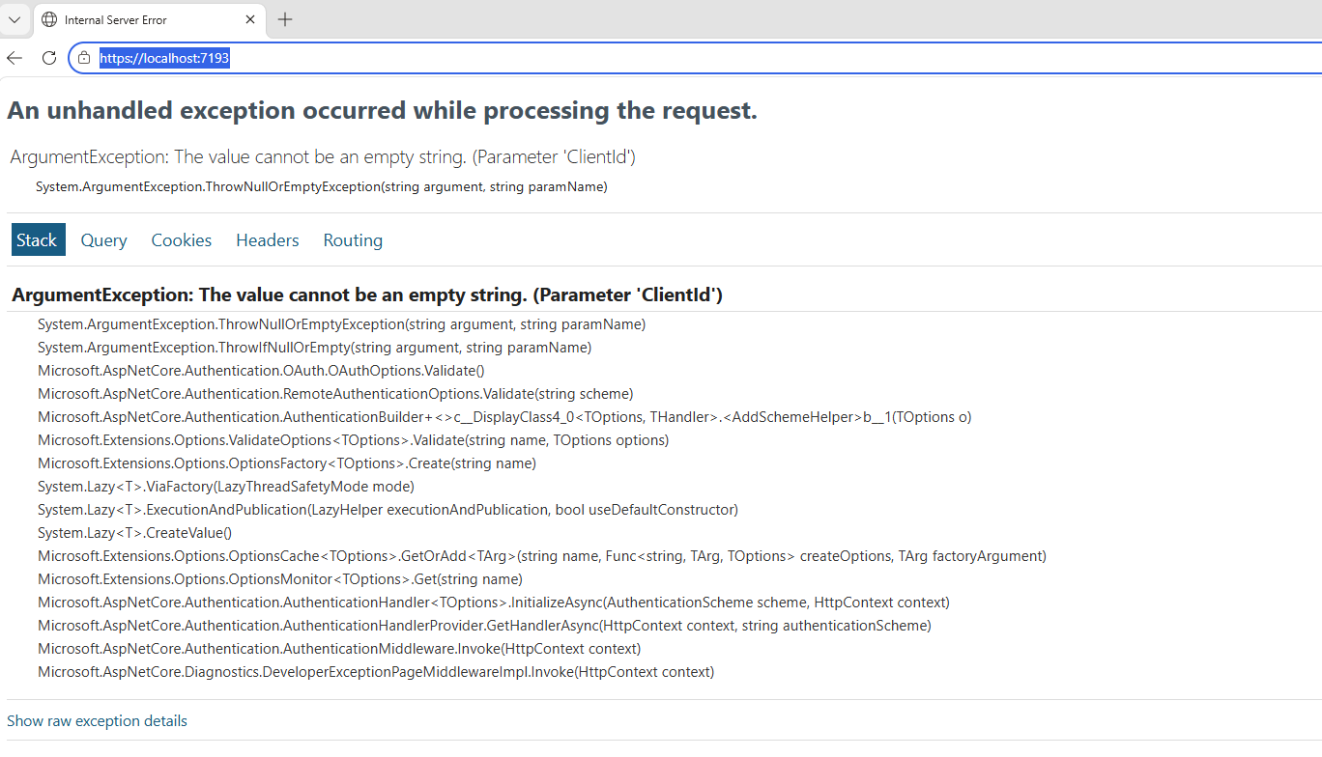
- Authorized JavaScript Origin =https://localhost:7193
- Authorized redirect URIs=https://localhost:7193/signin-google
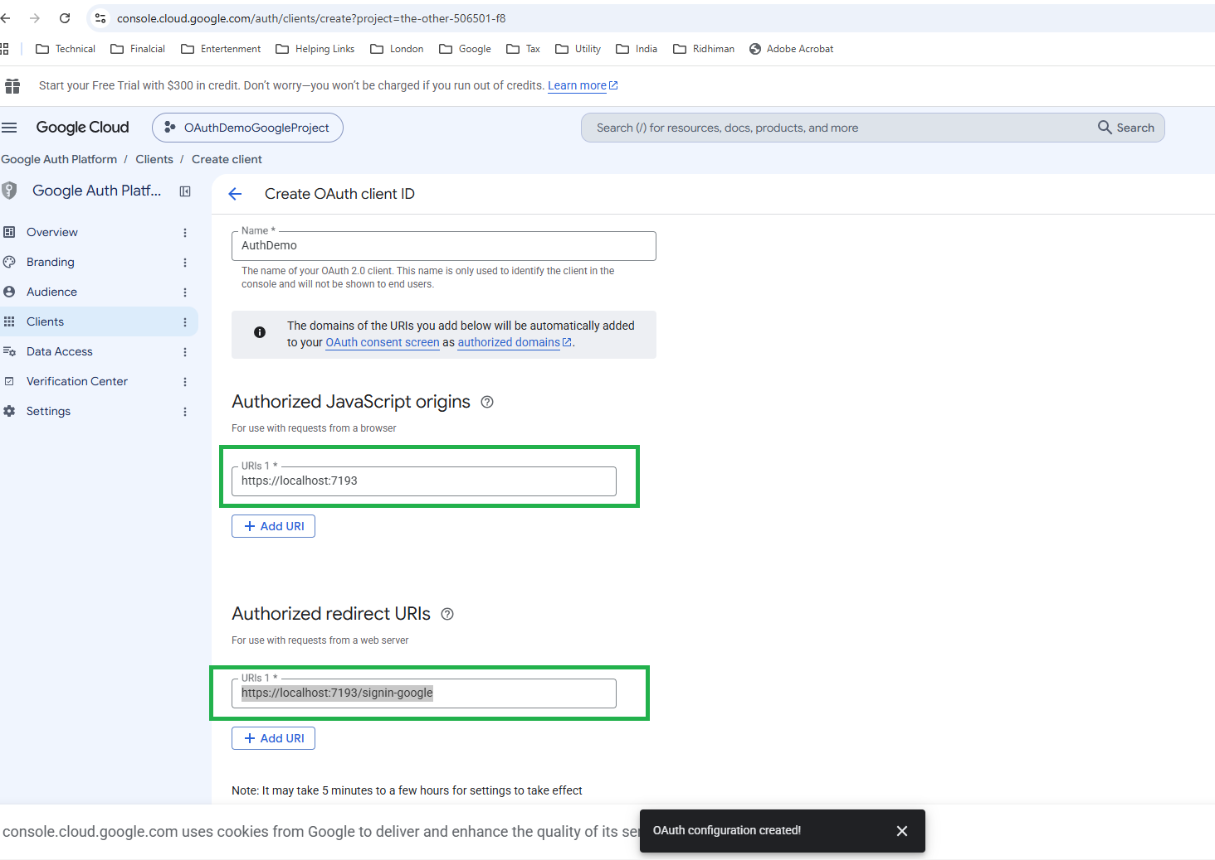

- Click on the ‘Create’ Button and Click ‘OK’ button and download the JSON file

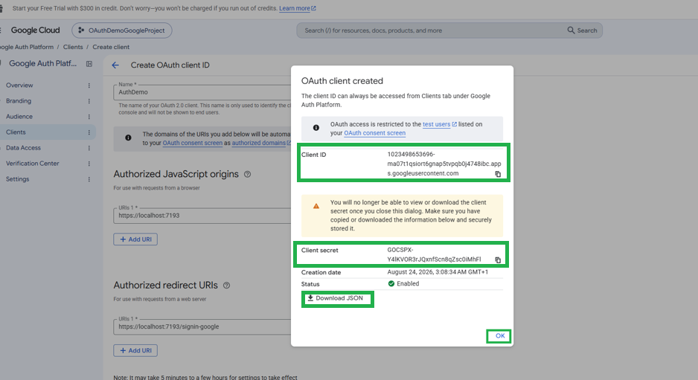

https://console.cloud.google.com/auth/clients?project=the-other-506501-f8

- Copy the ‘ClientId’ and ‘ClientSecret’ and paste them into ‘appsettings.json’
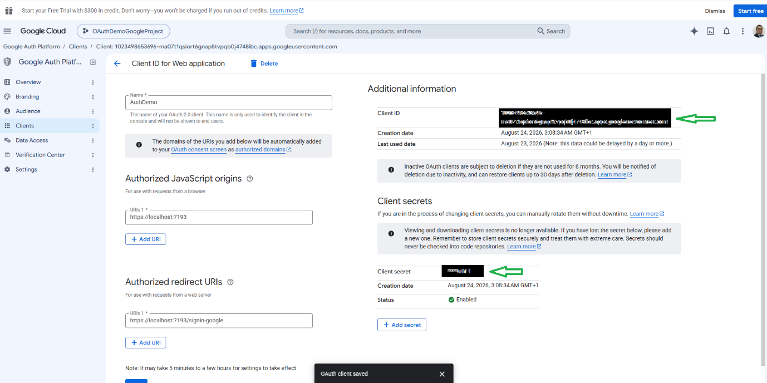

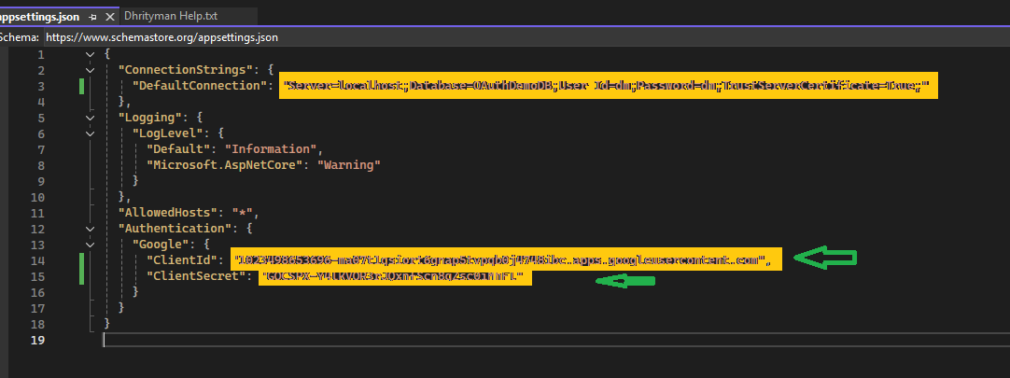

- Execute the Project and check the behaviour of the project

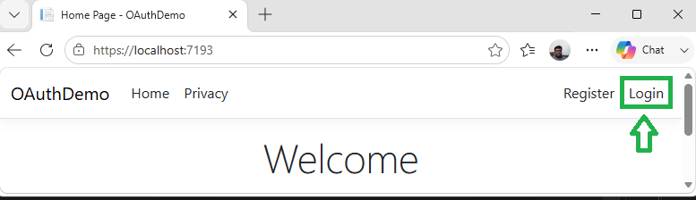

- Click on the Google button

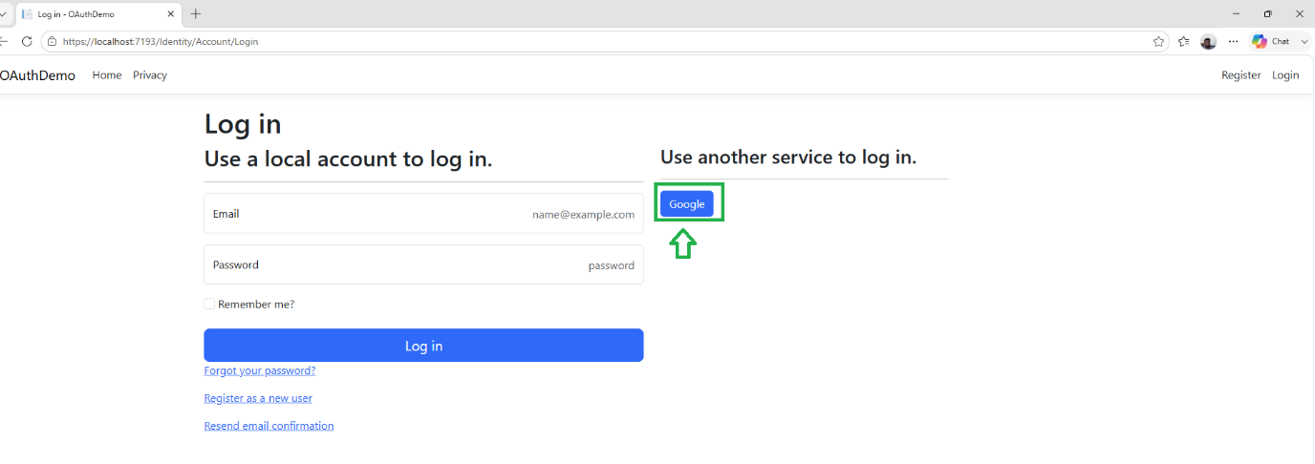

- Log in with a Google account

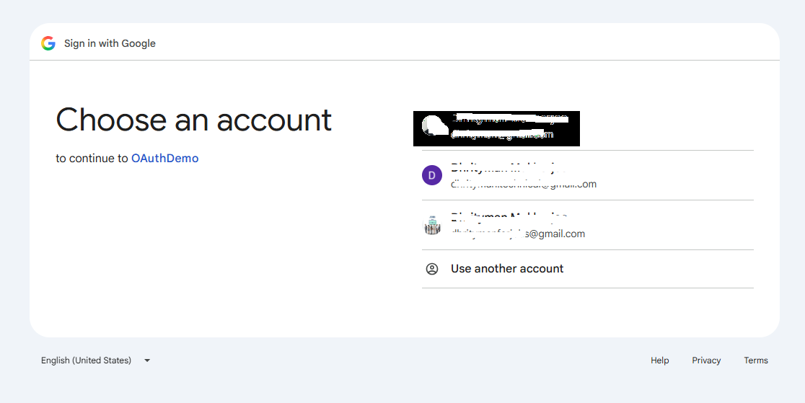

- Check the running Project Web site

